Eduardo Lara Stages Experiences
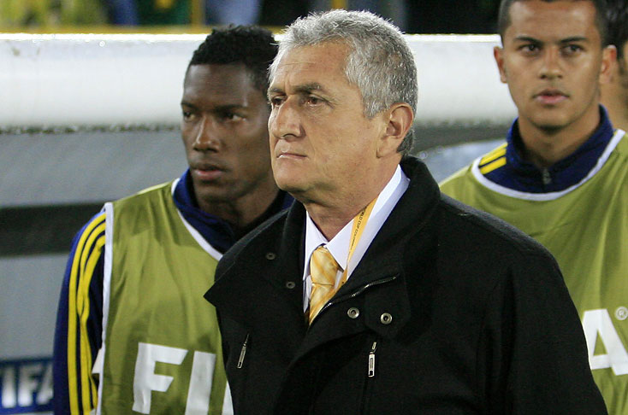

Stages:
1991- International Football Seminar, Cali (Carlos Salvador Bilardo)
1992- International Football Seminar, Cali (Fabio Capello, Francisco Maturana, Edson Arantes Donascimento "Pele", Hernan Dario Gomez)
1995 - International Football Seminar, Cali (Arrigo Sacchi)
1996 - Seminar " Sports training factors for improve fitness", Cali
1997 - National Seminar on methodology and practice of football in the lower divisions, Cali. International modern football seminar, Cali (Christofer Rocholl). Football Workshop Seminar, Medellin (Francisco Maturana, Juan Jose' Pelaez, Reinaldo Rueda).
1999 - Seminar "Football Forever", Cali (Juan Josè Pelaez, Javier Fernandez)
2001- Seminar "Football Forever", Santiago de Cali (Sergio Markarian, Luis Felipe Scolari, Julio Cesar Uribe).
2002 - International modern football seminar, Santiago de Cali (Peater Schreiner).
2003 - FIFA stage for football coaches, Asuncion/Paraguay (FIFA teachers, England)
2004 - International Seminar on Football and national sports games, Colombia (Richard Perez)
2005 - FIFA Report and Statistics Seminar, Netherlands
2009 - FIFA stage on technique preparation and direction in football, Colombia (Mariano Moreno). FIFA stage (ODEPA) continental high level football, Messico (Mariano Moreno)
2012/14 - Stage technique director professional ATFA, Buenos Aires

